Automated CI/CD Pipeline with Docker and Kubernetes

End-to-End DevOps Automation using GitHub, Jenkins, Maven, Ansible, Docker, DockerHub and Kubernetes

1. Project Introduction
This project demonstrates an end-to-end DevOps automation workflow for building, containerizing and deploying a web application using GitHub, Jenkins, Maven, Ansible, Docker, DockerHub and Kubernetes.
The application code is pushed to GitHub, after which Jenkins automates the CI/CD process. Jenkins pulls and builds the application using Maven, while Ansible automates tasks between the Docker and Kubernetes environments.
Docker creates the application image and pushes it to DockerHub. Finally, Kubernetes pulls the image from DockerHub, deploys the application using Pods and a Service, and makes it accessible through the worker node's public IP address.

2. Technologies Used
Technology | Purpose
Git | Version control
GitHub | Source-code repository
Jenkins | CI/CD automation
Maven | Application build and testing
Ansible | Server automation and configuration
Docker | Application containerization
DockerHub | Container image registry
Kubernetes | Container orchestration
Linux | Server operating system
Bash/Shell | Automation and server commands
Dockerfile | Docker image creation instructions
Kubernetes YAML | Application deployment configuration
Nginx | Web server/container base image
HTML | Sample web application

3. Project Architecture
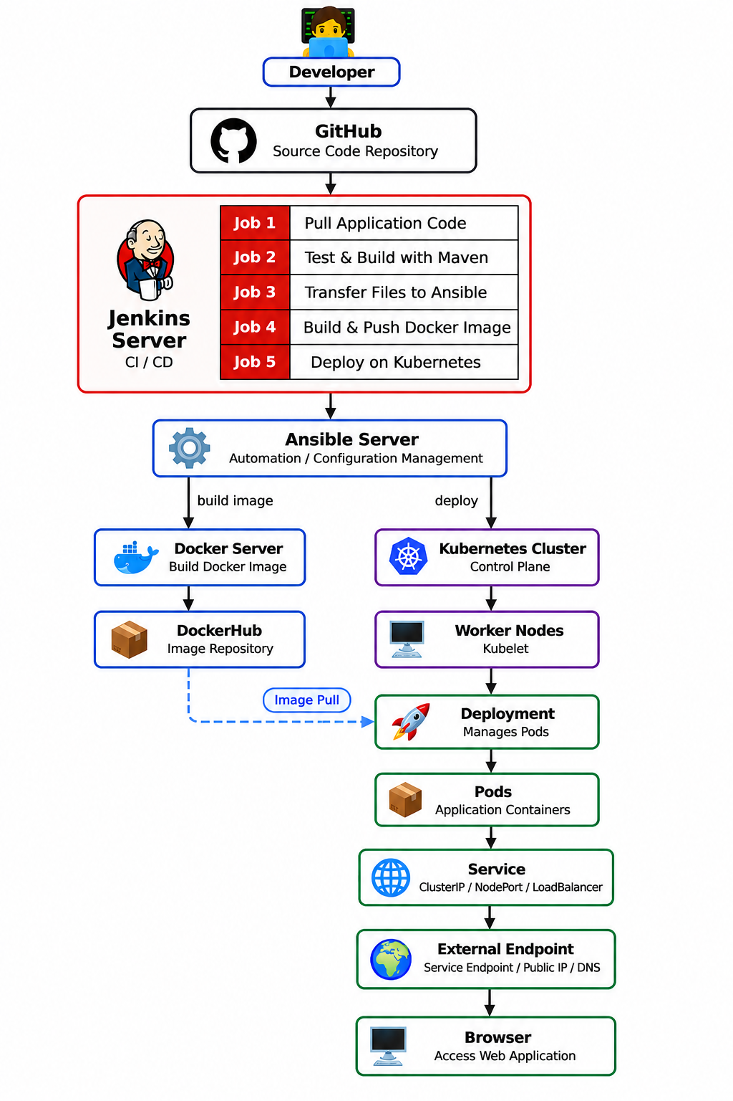

4. Project Objective
The main objectives of this project are:
- Store application source code in GitHub.
- Automate application deployment using Jenkins.
- Pull application source code automatically from GitHub.
- Test and build the application using Maven.
- Transfer application and deployment files using Jenkins.
- Use Ansible for automation between servers.
- Build a Docker image from the application.
- Push the Docker image to DockerHub.
- Create and configure a Kubernetes cluster.
- Deploy the application using Kubernetes Deployment.
- Expose the application using a Kubernetes Service.
- Make the application accessible through a public IP address.
- Demonstrate an end-to-end CI/CD and container orchestration workflow.

5. Step-by-Step Project Implementation

Step 1: Launch Developer Server
The first step of the project is to launch the developer server.
The developer server is used to create and maintain the application source code and project-related files.
The required application files are created on this server.
The developer server acts as the starting point of the complete DevOps workflow.
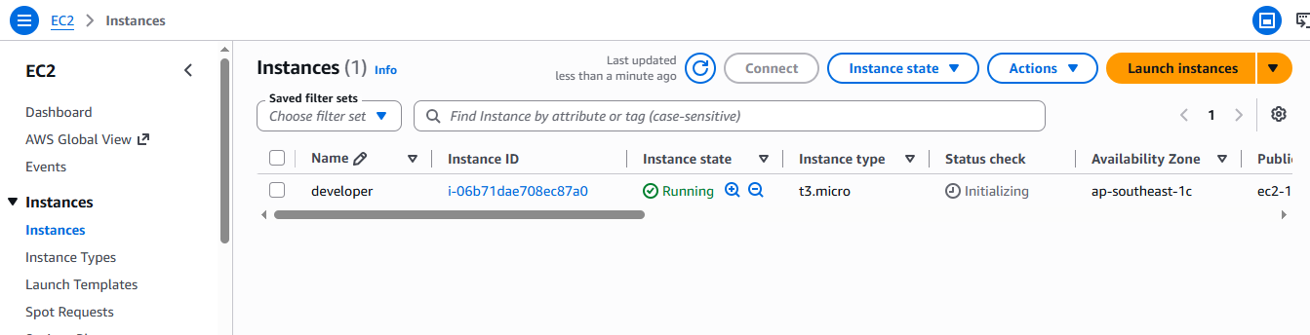

Step 2: Developer Creates Application Files and Pushes Them into Git
After launching the developer server, the developer creates the application source code and required project files.
The application source code contains the website or application files. The additional project files are used during the build, containerization and deployment process.
The files are added to Git using:
git add .
A commit is then created:
git commit -m "Add application files"
The repository is then connected to GitHub.
The basic Git workflow is:
Create Files
↓
git add
↓
git commit
↓
git push

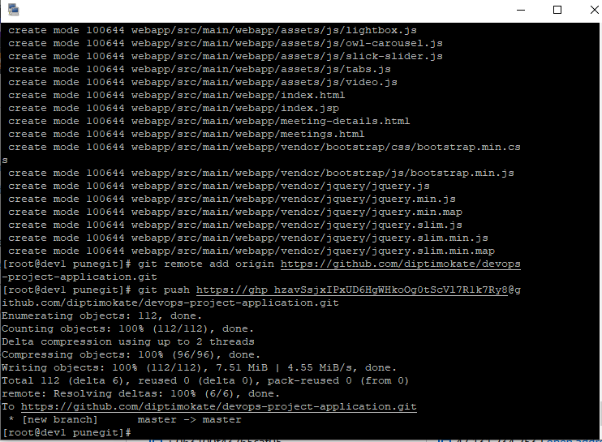

Step 3: Files Are Successfully Pushed to GitHub
After committing the files, they are pushed to the GitHub repository.
Example:
git push -u origin main
The GitHub repository now contains the application source code and required project files.
The repository acts as the centralized source-code repository for the complete project.
Jenkins uses this GitHub repository to pull the latest application code.
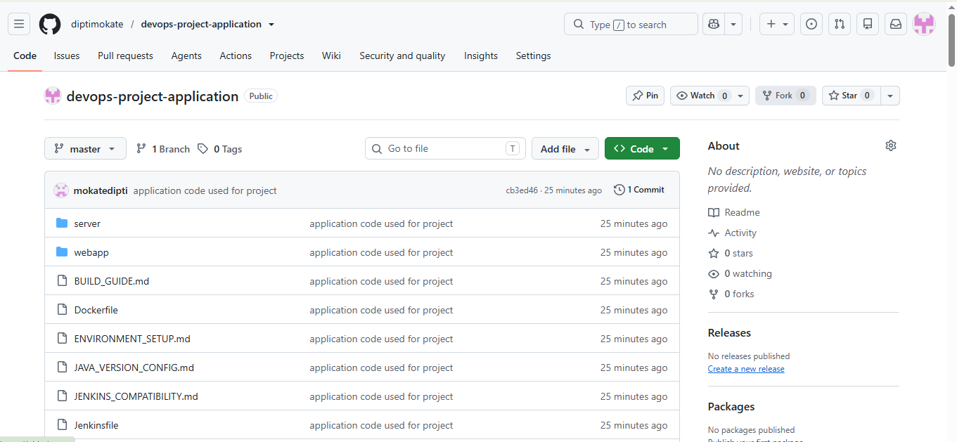

Step 4: Launch Jenkins Server
The next step is to launch the Jenkins server.
Jenkins is used as the automation and CI/CD server for the project.
Jenkins performs different tasks throughout the project, including:
- Pulling application code from GitHub.
- Testing and building the application.
- Transferring required files to Ansible.
- Creating the Docker image.
- Pushing the Docker image to DockerHub.
- Deploying the application on Kubernetes.
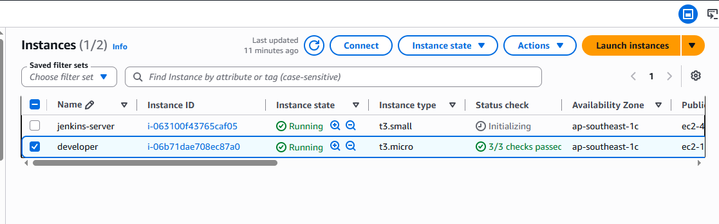

Step 5: Creating the First Jenkins Job – Pull Application Code from GitHub
The first Jenkins project is created to pull the application source code from GitHub.
The basic workflow is:
GitHub
↓
Jenkins
↓
Application Source Code
↓
Jenkins Workspace
Jenkins connects to the GitHub repository and pulls the latest version of the application source code.
The application files are stored in the Jenkins workspace after the successful build.
The first Jenkins job ensures that the latest source code is available for the next stages of the CI/CD pipeline.
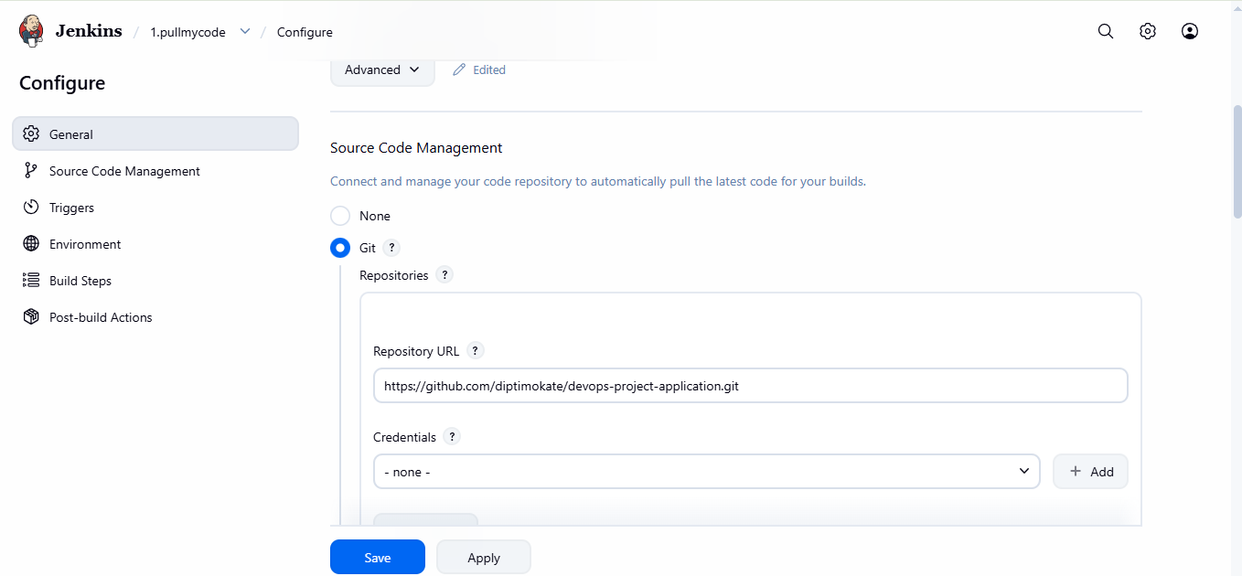
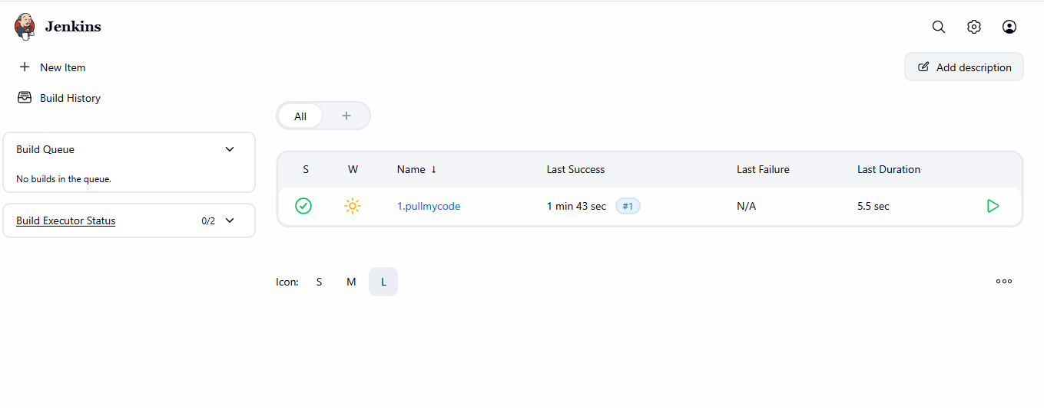

Step 6: Jenkins Successfully Pulls the Application Source Code
After the first Jenkins job is executed successfully, the application source code is pulled from the GitHub repository.
The successful build confirms that Jenkins can successfully connect to GitHub and access the repository.
The application code is now available inside the Jenkins workspace.
The source code can be used for the testing and build stage.
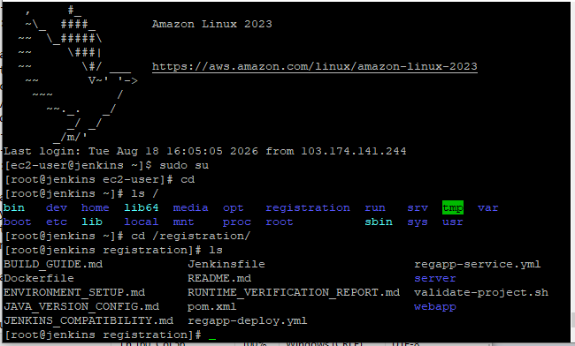

Step 7: Install Git and Maven for Application Build
Git and Maven are required for the application build process.
Git is used to manage and pull the application source code.
Maven is used for:
- Managing application dependencies.
- Testing the application.
- Building the application.
- Creating the application artifact.
The Jenkins server is configured with the required Git and Maven environment.
Example Maven commands:
mvn clean test
For creating the application build:
mvn clean package
The exact build command depends on the application.
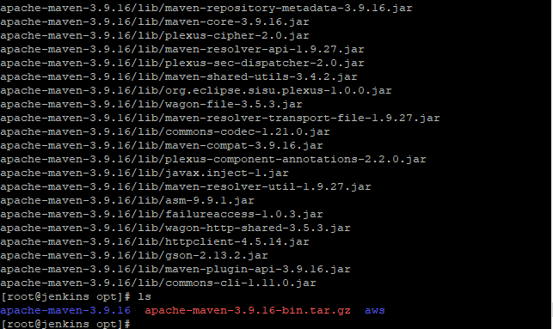

Step 8: Creating the Second Jenkins Job – Test and Build the Application
The second Jenkins job is created to perform the Continuous Integration process.
The application code pulled from GitHub is tested and built using Maven.
The basic workflow is:
Application Source Code
↓
Maven Test
↓
Maven Build
↓
Application Artifact
The Jenkins job automatically performs the required build operations.
If the build is successful, the application is ready for the next deployment stages.
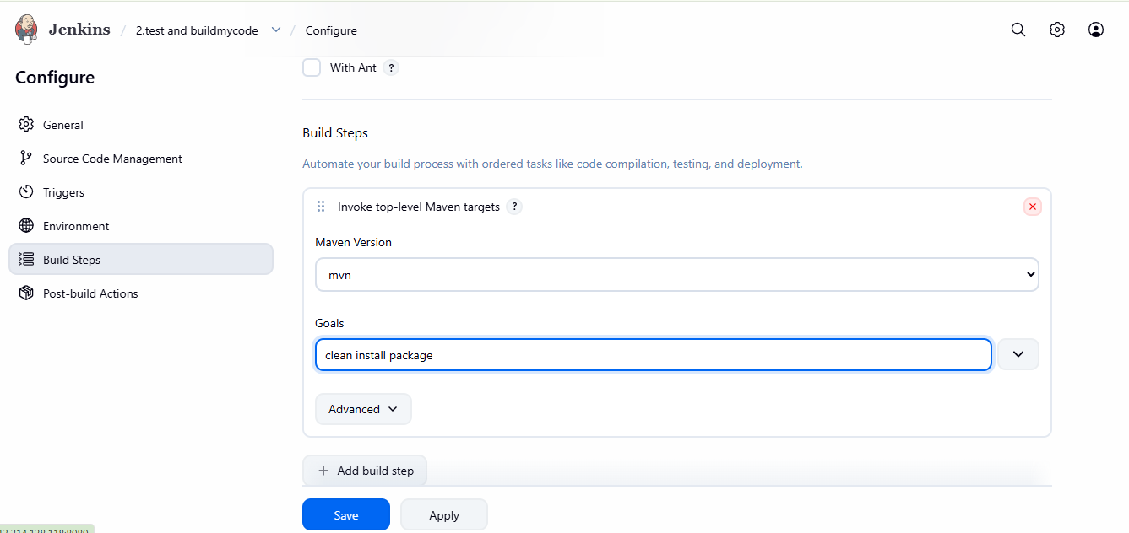
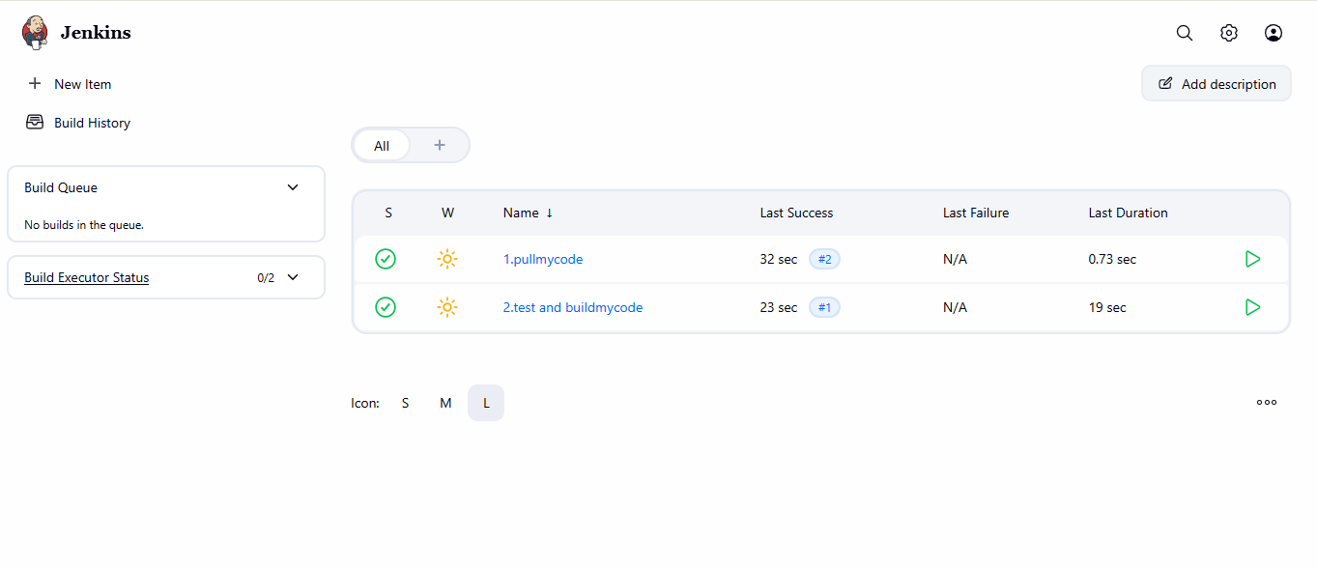

Step 9: Launch Ansible Server
The next step is to launch the Ansible server.
The Ansible server is used for server automation and configuration management.
The Ansible server is responsible for automating tasks on the Docker server and Kubernetes environment.
The general workflow is:
Jenkins
↓
Ansible
↓
+-----------------------+
↓ ↓
Docker Server Kubernetes Server
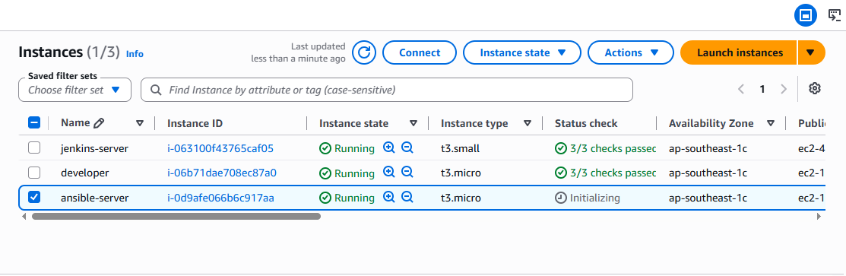

Step 10: Creating the Third Jenkins Job – Transfer Files to Ansible Server
The third Jenkins job is created to transfer the required application and deployment files to the Ansible server.
The Jenkins job sends the required files to the Ansible server.
The transferred files may include:
- Application files.
- Dockerfile.
- Ansible playbooks.
- Kubernetes Deployment YAML file.
- Kubernetes Service YAML file.

The workflow is:
Jenkins
↓
Application / Deployment Files
↓
Ansible Server
The Ansible server now contains the required files for automation.



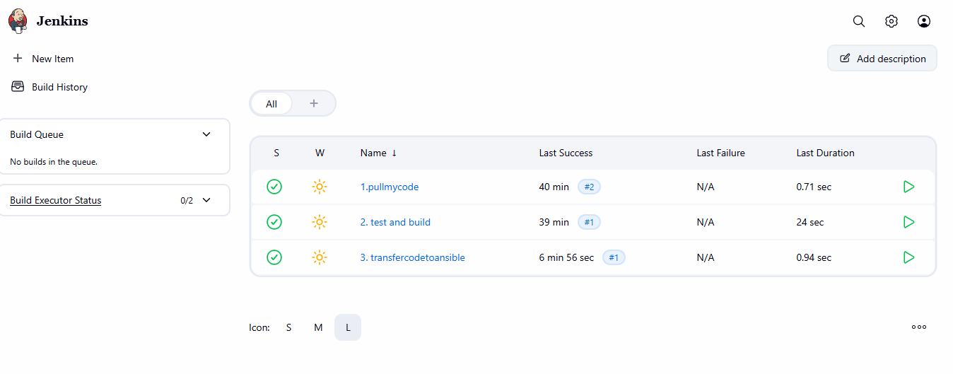

Step 11: Launch Docker Server
The next step is to launch the Docker server.
The Docker server is used to containerize the application.
Docker is responsible for:
- Receiving the application files.
- Reading the Dockerfile.
- Creating the Docker image.
- Tagging the Docker image.
- Pushing the Docker image to DockerHub.
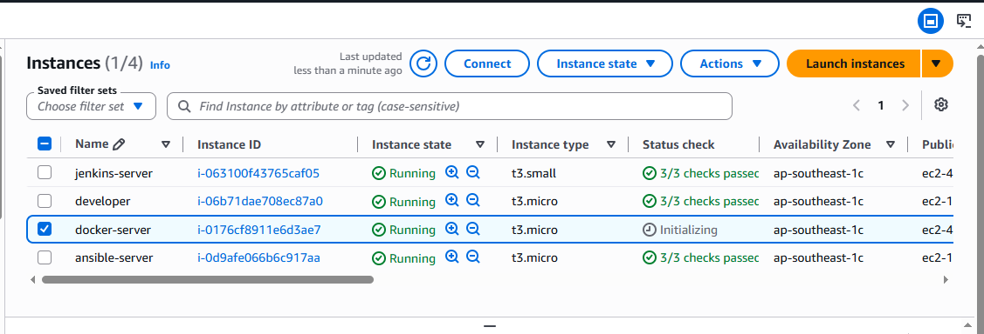

Step 12: Create DockerHub Repository
A DockerHub repository is created to store the application container image.
DockerHub acts as a centralized container image registry.
The image created by Docker is uploaded to DockerHub.
The general workflow is:
Docker Server
↓
Docker Image
↓
DockerHub Repository
The Kubernetes cluster later pulls the application image from DockerHub.
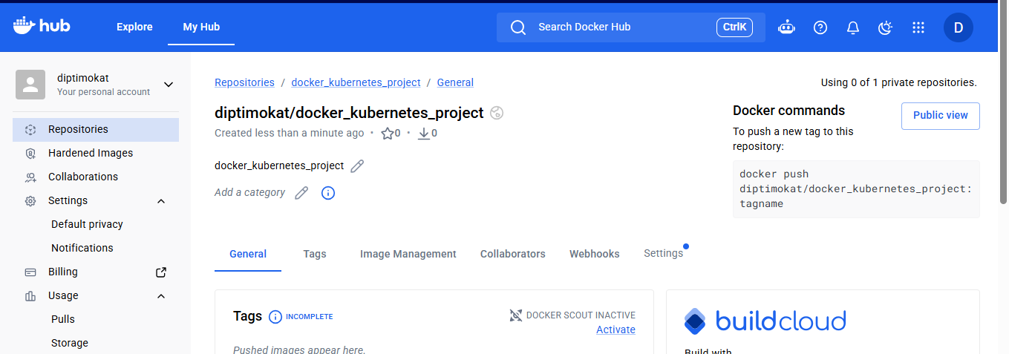

Step 13: Creating the Fourth Jenkins Job – Build and Push Image to DockerHub
The fourth Jenkins job is created to automate Docker image creation and upload.
The Jenkins job performs the following operations:
- Pulls or receives the application files.
- Uses the Dockerfile.
- Builds the Docker image.
- Tags the image with the DockerHub repository name.
- Pushes the image to DockerHub.
The basic workflow is:
Application Source Code
↓
Dockerfile
↓
Docker Build
↓
Docker Image
↓
DockerHub
Example Docker build command:
docker build -t <dockerhub-username>/<repository-name>:latest .
The Docker image is then pushed to DockerHub.
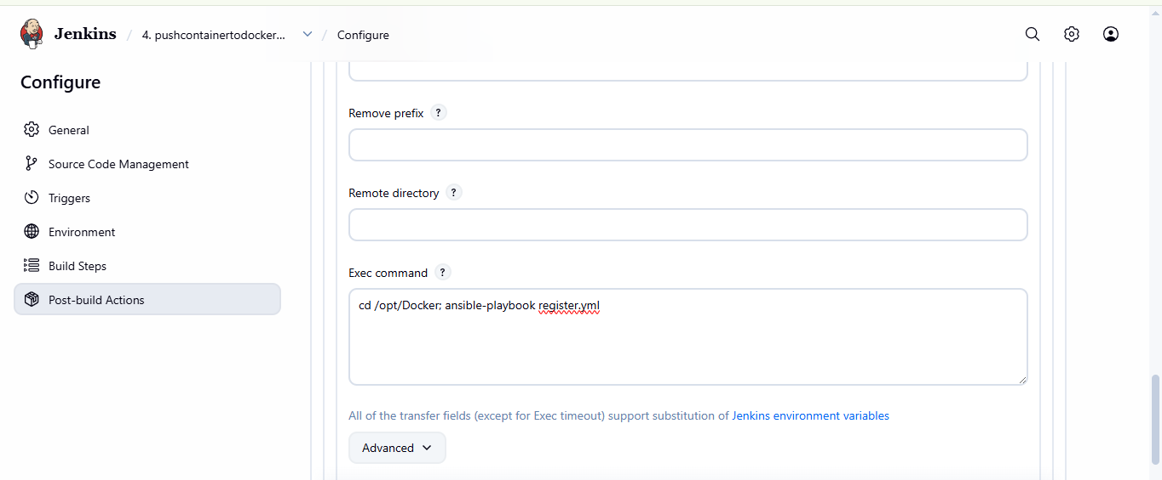

Step 14: Application Docker Image Is Successfully Pushed to DockerHub
After the Docker image is successfully created, it is pushed to DockerHub.
Example login command:
docker login
Then the image is pushed using:
docker push <dockerhub-username>/<repository-name>:latest
DockerHub now contains the application image.
The DockerHub repository acts as the container image registry from which the Kubernetes cluster can pull the application image during deployment.
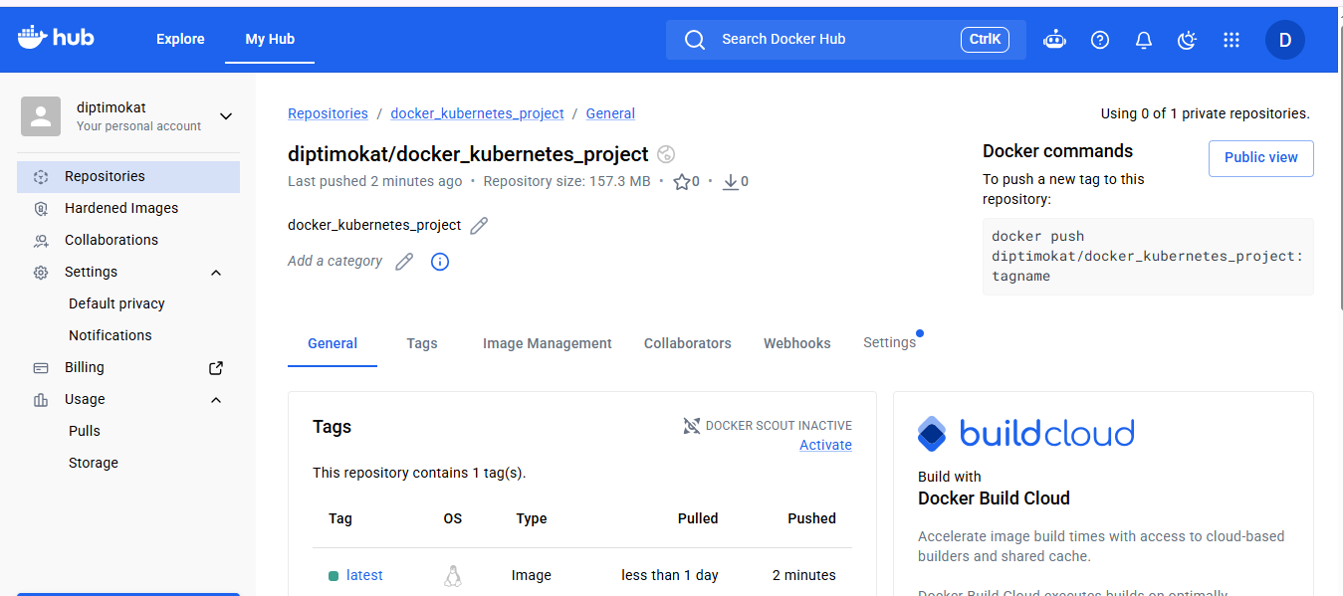

Step 15: Launch Kubernetes Server
The next step is to create the Kubernetes environment.
The Kubernetes cluster contains:
- Control Plane / Master Node.
- Worker Node or Nodes.
The control plane manages the Kubernetes cluster.
The worker nodes run the application Pods.
The Kubernetes environment is used to deploy and manage the containerized application.
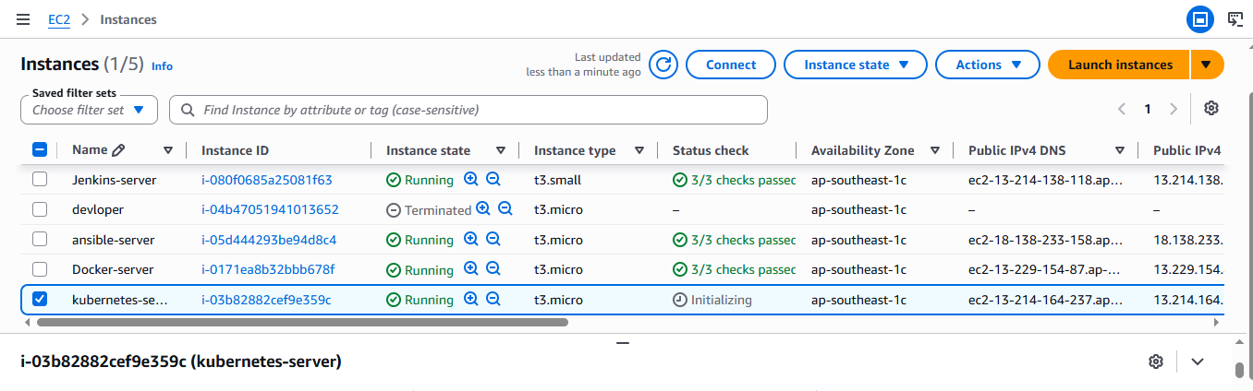

Step 16: Ansible Connects to Docker Server and Kubernetes Environment
After configuring the Ansible server, Ansible is used to communicate with the required servers.
The Ansible server connects to:
- Docker Server.
- Kubernetes Control Plane.
- Kubernetes Worker Nodes.
The workflow is:
Ansible Server
↓
+--------------------------+
↓ ↓
Docker Server Kubernetes Cluster
↓ ↓
Build Image Deploy Application
Ansible automates the required remote operations.
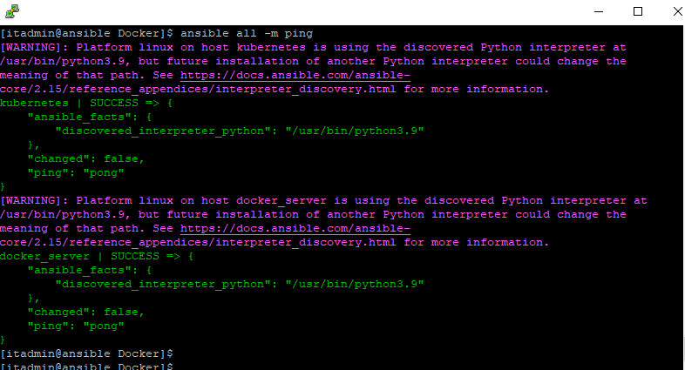

Step 17: Kubernetes Nodes Are Ready
After the Kubernetes cluster is configured, the nodes are verified.
The following command is used:
kubectl get nodes
The Kubernetes cluster is now ready for application deployment.
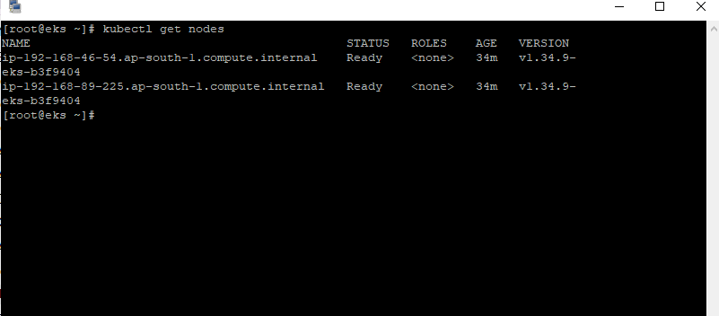

Step 18: Create Kubernetes Deployment and Service Files
The Kubernetes Deployment YAML file is used to deploy the application.
The Deployment file defines:
- Application name.
- Number of replicas.
- Docker image.
- Container configuration.
- Application labels.
The Kubernetes Service YAML file is used to expose the application.
The Service defines:
- Service name.
- Service type.
- Application selector.
- Port configuration.
- Target port.
The general workflow is:
DockerHub Image
↓
Kubernetes Deployment
↓
Application Pods
↓
Kubernetes Service
↓
Browser Access

Step 19: Kubernetes Creates Application Pods
The Kubernetes Deployment file is applied to the cluster.
Example:
kubectl apply -f deployment.yml
The Service file is then applied:
kubectl apply -f service.yml
Kubernetes pulls the application image from DockerHub and creates the required Pods.
The Pods can be verified using:
kubectl get pods
The Service can be verified using:
kubectl get svc

Step 20: Creating the Fifth Jenkins Job – Deploy Application on Kubernetes
The fifth Jenkins job is created to automate the application deployment process.
The Jenkins job triggers the Kubernetes deployment process.
The application image is pulled from DockerHub and deployed on the Kubernetes cluster.
The workflow is:
DockerHub
↓
Application Image
↓
Jenkins Job
↓
Kubernetes
↓
Deployment
↓
Pods
↓
Service
The application is now deployed on the Kubernetes environment.
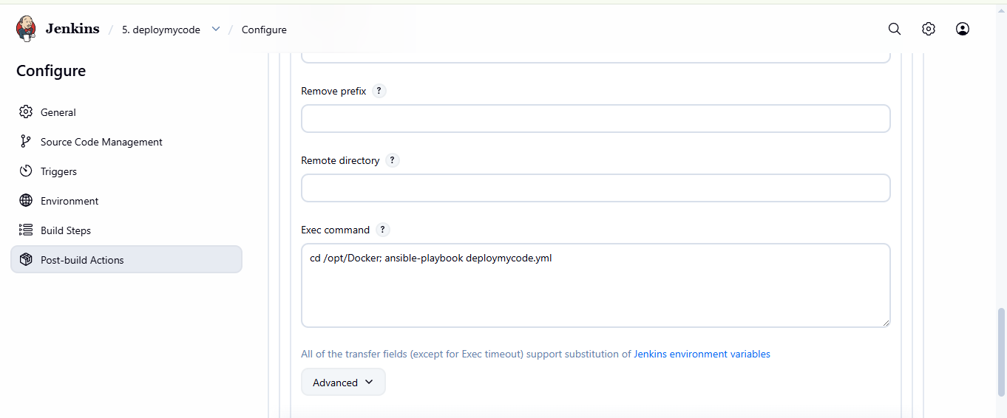

Step 21: Verify Kubernetes Pods and Service
After successful deployment, the Kubernetes resources are verified.
Check the Pods:
kubectl get pods
Check the Deployment:
kubectl get deployment
Check the Service:
kubectl get svc
The Pods should be in the Running state.
The Service should expose the application correctly.
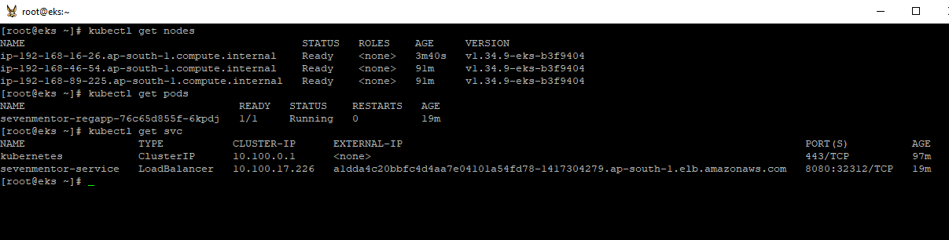

Step 22: Application Accessible Through Browser
The final step is to access the deployed application.
Once the Kubernetes Deployment and Service are successfully created, the application becomes accessible through the Kubernetes Service.
For a NodePort service, the worker node public IP and NodePort are used.
Example:
http://<WORKER_PUBLIC_IP>:<NODEPORT>
The exact public IP address and port depend on the Kubernetes Service configuration.
The successful browser access confirms that the complete DevOps CI/CD pipeline is working correctly.


Step 23: All jobs and complete project view
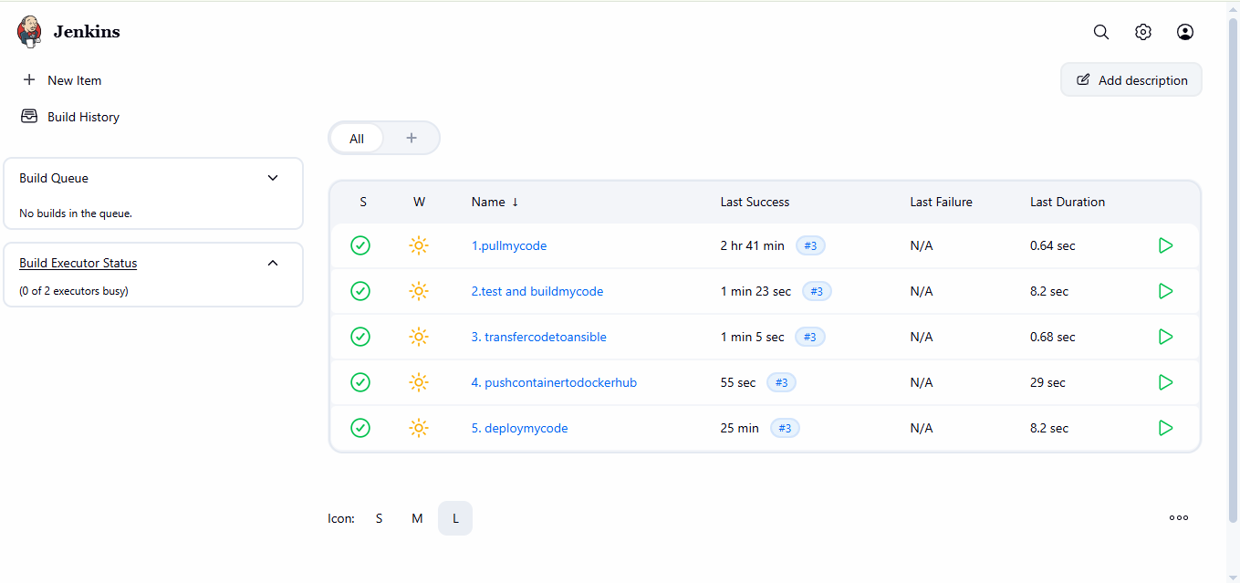

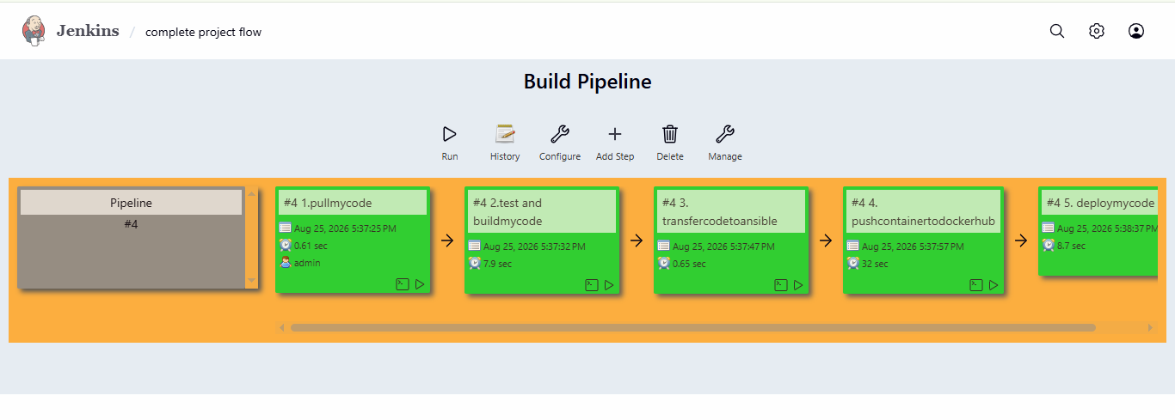

6. Complete Project Flow
The complete project can be summarized as:
1 : Launch Developer Server
↓
STEP 2 : Create Application Files
↓
STEP 3 : Push Files to GitHub
↓
STEP 4 : Launch Jenkins Server
↓
STEP 5 : Create First Jenkins Job to Pull Code
↓
STEP 6 : Jenkins Successfully Pulls Code
↓
STEP 7 : Configure Git and Maven
↓
STEP 8 : Test and Build Application
↓
STEP 9 : Launch Ansible Server
↓
STEP 10 : Transfer Files to Ansible
↓
STEP 11 : Launch Docker Server
↓
STEP 12 : Create DockerHub Repository
↓
STEP 13 : Build Docker Image Through Jenkins
↓
STEP 14 : Push Docker Image to DockerHub
↓
STEP 15 : Launch Kubernetes Cluster
↓
STEP 16 : Configure Ansible Connectivity
↓
STEP 17 : Verify Kubernetes Nodes
↓
STEP 18 : Create Deployment and Service Files
↓
STEP 19 : Create Application Pods
↓
STEP 20 : Deploy Application Through Fifth Jenkins Job
↓
STEP 21 : Verify Pods and Service
↓
STEP 22 : Access Application Through Browser

7. Final Project Result
The project successfully demonstrates an end-to-end automated DevOps deployment workflow.
The application starts from the developer server and is pushed to GitHub.
Jenkins then automates the different CI/CD stages. The application source code is pulled from GitHub, tested and built using Maven, and transferred for further automation.
Docker is used to create the application container image. The image is stored in DockerHub.
Ansible is used to automate operations between the required servers and environments.
The application image stored in DockerHub is then deployed on the Kubernetes cluster.
Kubernetes creates and manages the application Pods and Service.
Finally, the deployed application becomes accessible through the Kubernetes worker node public IP address and Service port.
Therefore, the complete project demonstrates the integration of:
Git + GitHub + Jenkins + Maven + Ansible + Docker + DockerHub + Kubernetes
into one automated DevOps workflow.

8. Conclusion
This project provides practical implementation of important DevOps concepts including source-code management, Continuous Integration, CI/CD automation, application building, configuration management, containerization, container image registry management and container orchestration.
The project demonstrates how different DevOps tools can work together in one automated deployment pipeline.
The application starts from the developer and moves through GitHub, Jenkins, Maven, Ansible, Docker, DockerHub and Kubernetes.
Jenkins automates the CI/CD process, Maven performs application build operations, Ansible manages automation tasks, Docker containerizes the application, DockerHub stores the container image and Kubernetes deploys and manages the application.
The final result is a working application deployed on a Kubernetes environment and accessible through the Kubernetes Service.
This project demonstrates the integration of:
Developer
↓
GitHub
↓
Jenkins
↓
Maven
↓
Ansible
↓
Docker
↓
DockerHub
↓
Kubernetes
↓
Browser

